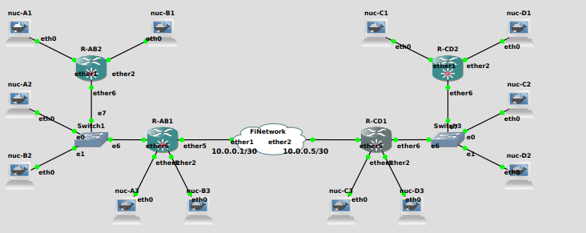

**RAB1:**

/ip address

add address=10.0.0.2/30 interface=ether5 network=10.0.0.0

/ip route

add gateway=10.0.0.1

interface/eoip/add name=eoip1 remote-address=10.0.0.6 tunnel-id=1

**RCD1:**

/ip address

add address=10.0.0.6/30 interface=ether5 network=10.0.0.4

/ip route

add gateway=10.0.0.5

interface/eoip/add name=eoip1 remote-address=10.0.0.2 tunnel-id=1